John Carroll

Comp 3700 HW 1

August 28th, 2015

(1)

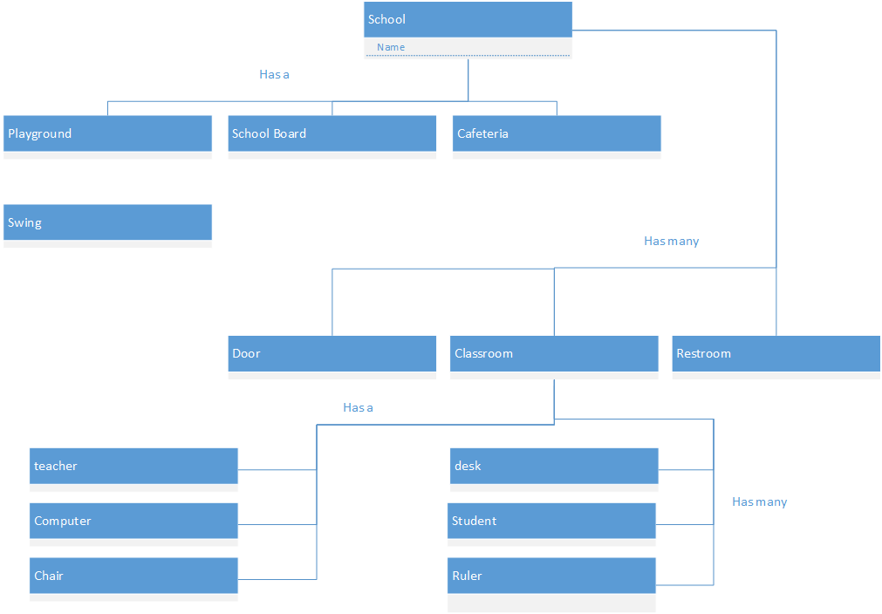

(2) Question 3.13 from the textbook



(3) Question 3.20 and 3.23 from the textbook

3.20



3.23



(4) Question 4.3 from the textbook

a.) aggregation

b.) association

c.) generalization

d.) aggregation

e.) generalization

f.) generalization

g.) association

h.) generalization

i.) aggregation

j.) association

k.) association

l.) association

(5) Question 4.15 from the textbook

